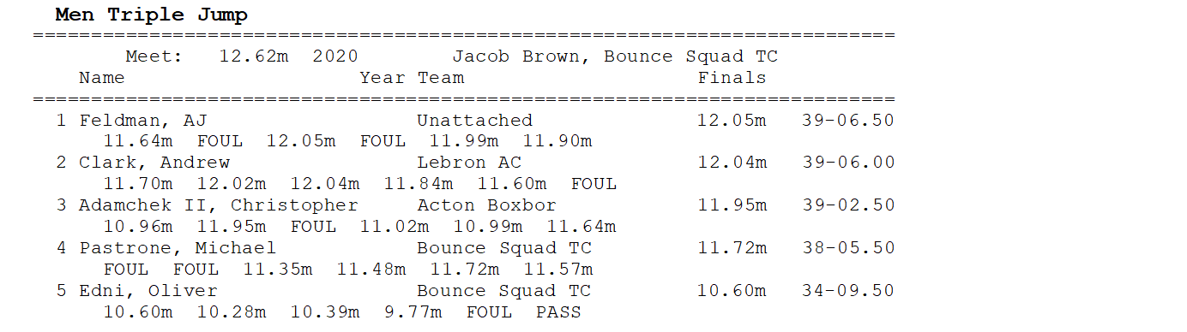

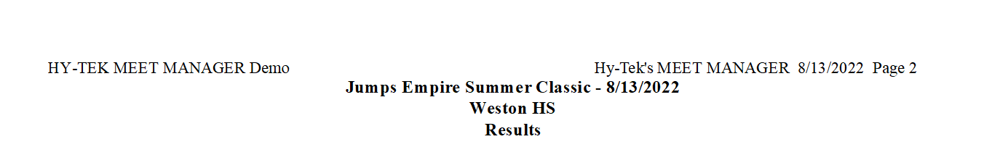

3



4



5